Soen341 Project

E/R model for database

Description of SQL tables

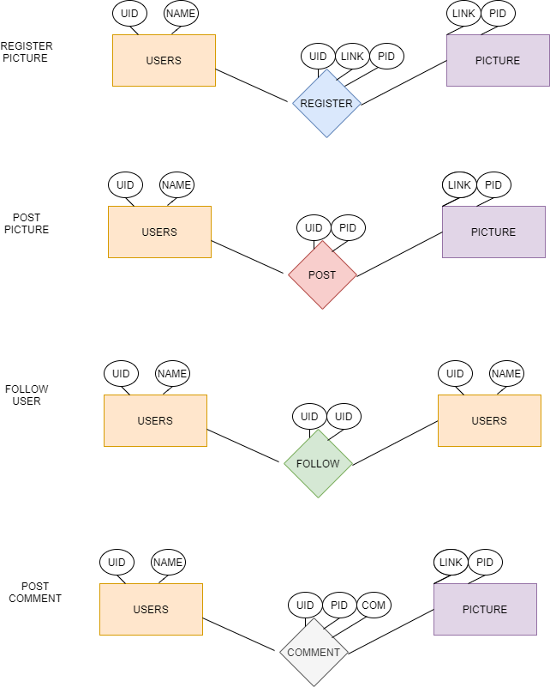

Fig1 E/R model

For posting pictures you will need USER table and PICTURE table to create REGISTER relation. Pictures will be stored away somewhere else from database but referenced with a link attribute. RESGISTER table will combine UID and LINK to provide a PIC. After registering picture, relation POST is used to combined UID and PID.

To follow a user FOLLOW relation is used to combine both UID of both users.

And to comment on a picture COMMENT relation is used to combine UID and PID to store comments on COM.